Figure 1.
 | Difference of Respirometer Readings in ml (Oxygen Consumed) Group 6 and Average Sets at 20 ° C and 10 ° C
Test Groups | 0 min. | 5 min. | 10 min. | 15 min. | 20 min.
Beads 6  (B 6 20°C) | 0 | 0.10 | 0.10 | 0.10 | 0.10
Dry Peas and Beads  (BP 6 20° C) | 0 | 0.24 | 0.24 | 0.24 | 0.24
Germinating Peas 6  (P 6 20 °C) | 0 | 0.06 | 0.13 | 0.19 | 0.27
Beads Average (AB 20° C) | 0 | 0.05 | 0.05 | 0.05 | 0.05
Dry Peas and Beads Average (APB 20° C) | 0 | 0.07 | 0.07 | 0.07 | 0.07
Germinating Peas Average (AP 20° C) | 0  (STDV 0) | 0.10  (STDV 0.10) | 0.17  (STDV 0.09) | 0.23  (STDV 0.09) | 0.30  (STDV 0.11)
Beads Average  (AB 10° C) | 0 | 0.46 | 0.47 | 0.48 | 0.43
Dry Peas and Beads Average (APB 10 °C) | 0 | 0.04 | 0.27 | 0.07 | 0.06
Germinating Peas Average (AP 10 °C) | 0  (STDV 0) | 0.08  (STDV 0.10) | 0.15  (STDV 0.09) | 0.18  (STDV 0.09) | 0.23  (STDV 0.8)

* STDV - standard deviation.

Figure 2.
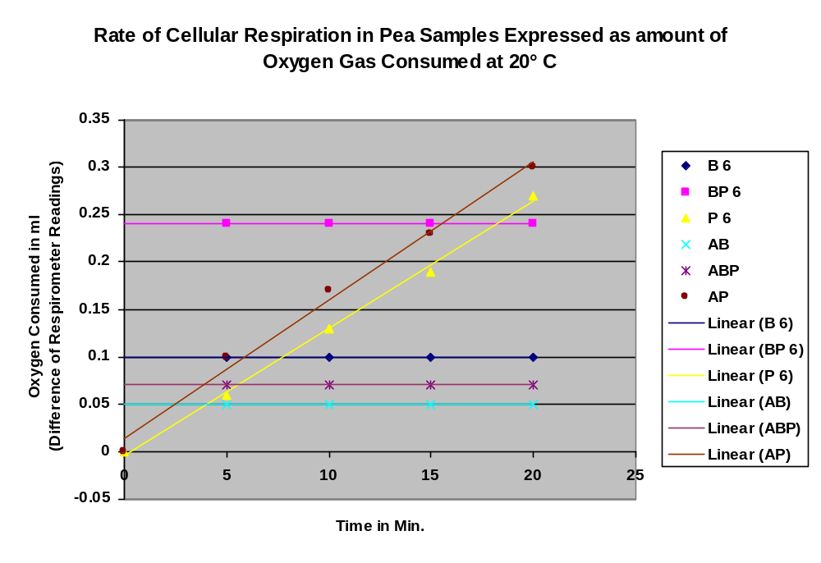Figure 3.

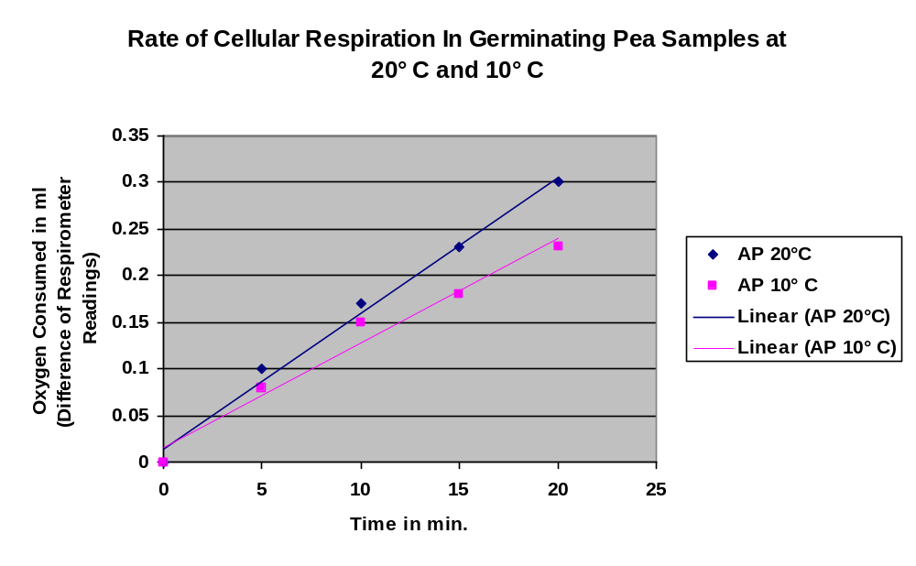
Noel Swanson
AP Biology
10/24/03
Cellular Respiration in Peas

Abstract

Cellular Respiration is the process carried on in the mitochondria of cells by which organic molecules are broken down, releasing energy and generating ATP through oxidative phosphorylation. During the process of aerobic cellular respiration, oxygen is consumed and carbon dioxide is released along with water vapor. This investigation sought to detect the evidence of cellular respiration in samples of germinating peas as well as assess the effects of change in temperature upon the rate of cellular respiration. Eight trials were conducted, three at 10° C and five at 20° C. Each trial consisted of three respirometers: two controls, one consisting of glass beads, another containing 25 dried peas along with enough glass beads to compensate for volume, and en experimental set consisting of 25 germinating peas. The consumption of oxygen was measured over a time interval of 20 minutes, and the effects of carbon dioxide production were nullified by the use of potassium hydroxide soaked cotton in the bottoms of the respirometer tubes. (KOH reacts with CO2 to form insoluble K2CO3.) Results showed that the germinating peas were the only sets to perform cellular respiration, and both the qualitative observation of water condensation forming inside the respirometers and the quantitative measurements of increasing levels of oxygen consumption for the germinating sets supported this conclusion. Averaged data from the two temperature groups indicate that the peas exhibit a more rapid rate of cellular respiration at 20° C than 10° C, a conclusion which runs counter to expected result of a lower rate of cellular respiration at higher temperatures given that the species of peas used was a type of Alaskan snow pea. Further experimentation under standard conditions and over a broader temperature spectrum will be necessary to fully analyze the results garnered from this investigation.

Hypothesis

If placed in aerobic conditions, then germinating peas will perform cellular respiration which can be detected by measuring the oxygen consumed, because if the peas are living they must undergo this process to survive, and oxygen being a reactant in the process this should prove a valid indicator, due to the laws of reaction rates which state that the rate of a chemical reaction is dependent upon the amount of reactants and products. Furthermore, the reaction rate will decrease at higher temperature because the type of species of pea used is adapted to colder environment, and therefore its enzymes would be better adapted to operating under cold conditions.

Null Hypothesis

If placed in aerobic conditions, either the peas will not perform cellular respiration, or monitoring the oxygen consumed will prove to be an ineffective method for measuring reaction rate.

Backround

Aerobic cellular respiration is a catabolic process carried out by all aerobic organisms. It consists of three phases: Glycolysis, the Krebs Cycle, and the Electron Transport Chain (ETC). During Glycolysis (actually an anaerobic step) the organic molecule, quite often a sugar such as glucose, is broken down into two subunits, in the case of glucose, Pyruvate. Energy released is used to regenerate ADP forming ATP through substrate-level phosphorylation while the oxidation of the organic molecule reduces the coenzyme NAD+ to NADH (nicotinamide adenine dinucleotide). The organic subunit enters the mitochondria aided by transport proteins and coenzymes where it becomes the material for the Krebs Cycle, where enzymes complete the oxidation of the organic fuel, releasing carbon in the form of carbon dioxide and producing two more ATP molecules through substrate level phosphorylation along with the reduction of NAD+ to NADH and FAD to FADH2 (another coenzyme, flavin adenine dinuleotide). The ETC consists of a series of proteins of successively increasing electronegativity ending with a molecule of oxygen. Hydrogen ions are released from their coenzyme escorts and pumped into the inner membrane space through the movement of high energy electrons through the successive elements of the ETC. Thus an acidic concentration gradient is built up inside the inner membrane space, and the hydrogen ions diffuse out through the enzyme ATP synthase creating a proton-motive force used to carry out what is known as oxidative phosphorylation. This process can generate between 30 to 34 molecules of ATP and accounts for the general efficiency of cellular respiration.(Cambell et al. 2002)
The net chemical reaction for Cellular respiration is shown below using glucose as fuel:

C6H12O6 + 6O2 → 6CO2 + 6H2O + Energy (ATP + Heat)

Thus the cellular respiration can be measured one of three ways: oxygen consumed, carbon dioxide produced, and energy released. Like all chemical reactions, the rate of reaction is dependent upon the concentrations of products and reactants as well as temperature, which can effect both the kinetic behavior of particles and in the case of biological reactions such as cellular respiration, the functioning of enzymes critical to the reaction process. (Zumdahl 2000)

Results

Qualitative observation indicated the presence of water condensation on the inside of the respirometer containing the germinating pea sample, supporting the qualitative data which also showed evidence that the germinating peas were carrying out cellular respiration. In trial group 6 conducted at 20°
C, the amount of oxygen consumed by the germinating peas rose steadily from an initial point of 0 to 0.27 ml over the twenty minute trial period (Fig. 1). Calculations indicate the rate of oxygen consumption to be approximately 0.0134 ml/min. This proved to be slightly less than the rate determined from the average set of data. The average rate of cellular respiration at 20° C was 0.0146 ml/min. Figure 2 compares the data from trial group six to the average set of data for the same temperature reading. Figure 3 compares the average data sets for germinating peas at both 10° C and 20° C. The rate of respiration at 20° C was slightly greater than the rate at 10° C, the later being approximately equal to 0.0112 ml/min. The results of the control groups showed no evidence of cellular respiration, either water condensation or a changing rate of oxygen consumption.

Conclusion

As predicted by the hypothesis, only the germinating peas carried out cellular respiration. Glass beads are incapable of organic functions such as this, and the dry peas were dormant and unable to carry out cellular respiration. Some minor fluctuations in the control data were most likely due to inaccuracies in the equlilibration period (the most probable cause of the strangely large value for BP 6, figure 2), pressure disturbances such as a person leaning over the water, or variations of gas volume with slight changes in temperature. The ideal gas law predicts that the volume of a gas is directly proportional to temperature (a component known as Charles’ Law) and that volume is inversely proportional to pressure (Boyle’s Law). Thus slight variations in pressure or temperature could affect the volume of the oxygen gas in the respirometer and thus the reading of the water level. Therefore, though the moles of gas consumed in the reaction would not change, the volume of those moles would be altered and thus it would appear that the rate was slightly lesser or greater than it actually was. The seemingly impossible negative values obtained in some of the trials at lower temperatures could reflect these properties of gaseous behavior as well.
A comparison of the average sets of germinating peas for both temperature ranges showed a slightly greater rate attributed to the sample set at 20° C. The species of peas used were a type of Alaskan snow pea, and therefore it seemed logical that the peas would undergo greater cellular respiration under colder temperatures. The data is not as conclusive as it might first seem however, an analysis of the standard deviations of the average sets yielded values close to 0.10 ml for almost all points (Fig. 1) This margin of error is nearly a third of the average maximum readings taken at 20 min. and predicts a wide range of inaccuracies in measurement and testing procedure. Any number of factors from measurement technique or error to temperature and pressure difference could have created such a wide margin of error. A Q10 test done on the average rates of the two temperatures returned a value of 1.3, indicating that more than likely the difference in rates was due to physical factors as opposed to biological factors such as enzyme activity (log Q10 = [10/(T2 –T1)] log (K2/K1). Yet with such a wide standard deviation, such a value for the temperature coefficient holds little value. Another possibility is that a difference of 10 ° C is not large enough to show a marked increase or decrease in the activity of certain enzymes, but the effect of the increase in heat is enough to affect the kinetic motion of particles so as to increase the reaction rate. Further testing over a wider temperature range and utilizing greater standards of accuracy and precision will be necessary to fully interpret the data.

References

Campbell, Neil A. and Jane B. Reece. Biology: Sixth Edition. San Francisco: Benjamin Cummings, 2002, p. 156-173.

Zumdahl, Steven S. and Susan A. Chemistry: Fifth Edition. Boston: Houghton Mifflin Company, 2000, p. 559-592.

